**Linux Environment Variables**

**1.State the command for the following.**

**a.View current environment variables**

**Ans: printenv**

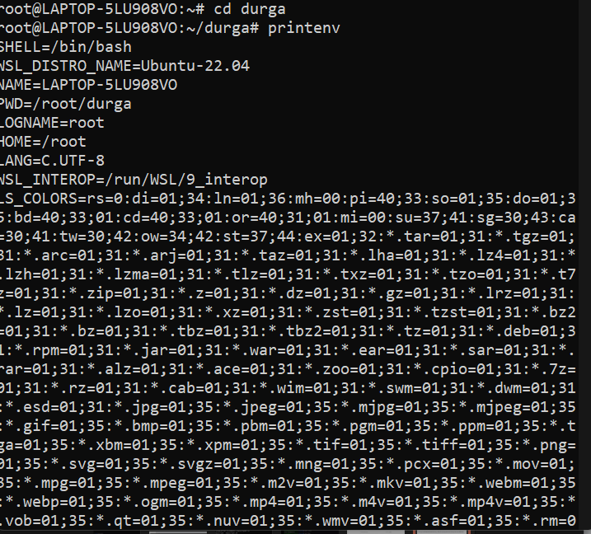

**b.display the PATH evirnment variable value**

**Ans: echo $PATH**

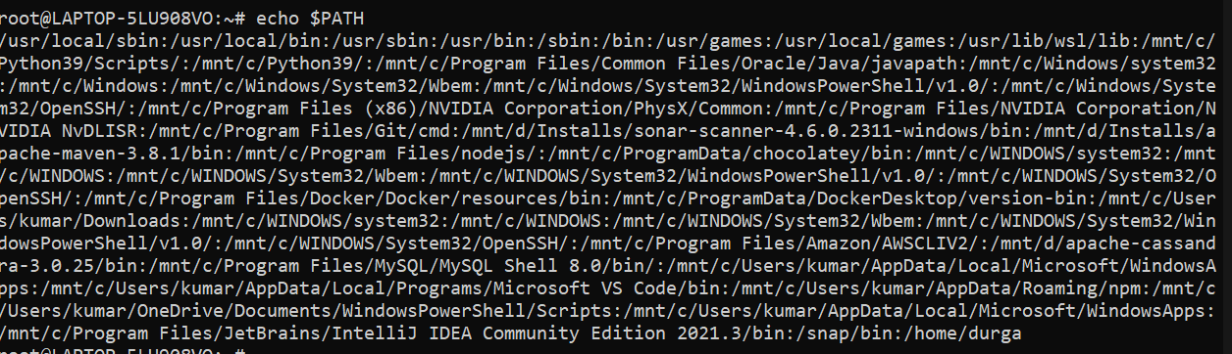

**c.update PATH to include the path to your home directory**

**Ans:PATH=$PATH:/home/durga**

**echo $PATH**

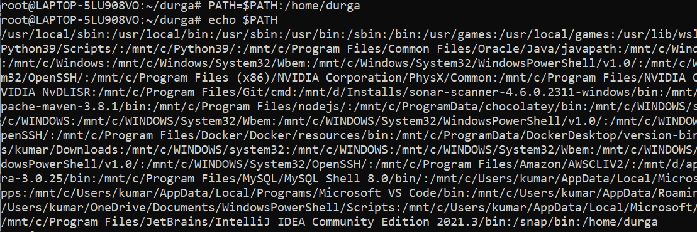

1. **How will you make the environment changes applicable to all users? Which script is to be modified?**

**Ans:** To make permanent changes to the environment variables for all new accounts, **go to your /etc/skel files, such as .** **bashrc , and change the ones that are already there or enter the new ones**. When you create new users, these /etc/skel files will be copied to the new user's home directory.

1. **I have installed an application named “myapp”. After installation, if I invoke the application, it fails with error as “Command myapp not found”. How will you fix this?**

**Ans:** In short, look for the following to fix “ bash: bashtop: command not found “: **Make sure the shell PATH variable correctly set and verify your PATH environment variable**. Verify that the file you want to execute or run exists on the Unix or Linux box. Some commands need to run as the superuser (root user). Ensure the software package is installed for missing command, and you have permission to run the command.